CLIENT PROJECT

SUPPLY CHAIN ANALYSIS

TEAM ID: PTID-CDA-OCT-25-803
PROJECT ID: CDACL-003-SUPPY CHAIN ANALYSIS

TEAM MEMBERS:
SR.NO | NAME | EMAILID
1 | ADITYA HINGRAJIYA | adityahingrajiya7@gmail.com
2 | AKSHAR PANCHAL | panchalakshar0687@gmail.com
3 | MEDHAKSHI PANDYA | pandyamedhakshi@gmail.com

INDEX

Sr.No | Content | Page no
1 | INTRODUCTION  - Supply chain overview  - Project objective  - Business significance | 3
2 | SUPPLY CHAIN PERFORMANCE DIAGNOSTICS  - KPIs used  - Measures used  - Business Interpretation  - Key insights  - Summary | 4
3 | CROSS-PATTERN BUSINESS INSIGHTS  - Demand synchronization  - Operational misalignment  - End-to-End performance | 20
4 | BUSINESS RECOMMENDATIONS  - Strategic alignment  - Performance optimization | 22
5 | CHALLENGES DURING EXECUTION | 23
6 | CONCLUSION | 25

INTRODUCTION

- Supply Chain Analysis involves the systematic evaluation of the flow of materials, information, and finances across all stages of the supply chain to improve efficiency, resilience, and cost effectiveness. In today’s competitive and customer centric marketplace, organizations must operate supply chains that are agile and guided by data and analytics. An optimized supply chain plays a critical role in ensuring product availability, reducing operational waste, and improving overall business performance.
- This project evaluates the company’s supply chain through a systematic application of operational data and analytical techniques across core business functions, including sales performance, inventory optimization, production efficiency, logistics operations, and quality assurance. The objective is to identify structural bottlenecks, operational inefficiencies, and cost drivers that materially impact business performance and limit operational effectiveness.
- The analysis examines how demand trends, inventory decisions, production planning, and logistics operations jointly influence key business outcomes such as cost efficiency, service reliability, and revenue performance. By clarifying these relationships, the project enables meaningful performance comparison and supports better managerial decision making, helping align operational execution with broader business objectives and supporting sustainable business growth.

SUPPLY CHAIN PERFORMANCE DIAGNOSTICS

This section is a structured supply chain performance review at key functional areas of sales, inventory, manufacturing, and logistics. The analytical framework supports the integrated approach to operational metrics and business indicators to determine supply chain efficiency, reliability, cost effectiveness, and identifies performance gaps and opportunities for improvement.
Following are the dashboards we have discussed below:
- Pattern-1: Sales and Revenue analysis
- Pattern-2: Inventory and Availability Overview
- Pattern-3: Manufacturing and Quality analysis
- Pattern-4: Logistics and Transaction performance
In detail:
Pattern-1: Sales and Revenue analysis:
This section examines sales and revenue trends across products, SKUs, and customer segments to assess revenue concentration, pricing effectiveness, and overall demand behaviour.
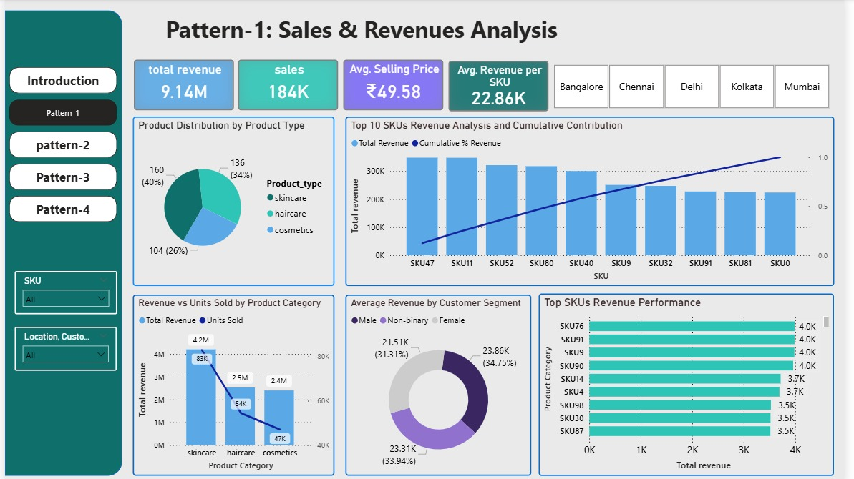

The following section presents the KPIs used, the underlying measures, business interpretation, key insights, and a summary of sales and revenue performance.
- KPIs used:
- Total Revenue:
Measures the total income generated from all product sales.
Indicates overall business performance and revenue scale.
- Total Sales (Units Sold):
Represents the total number of units sold across all products.
Reflects demand volume and market traction.
- Average Selling Price (ASP):
Shows the average price at which products are sold.
Helps evaluate pricing strategy and customer willingness to pay.
- Average Revenue per SKU:
Measures the average revenue generated by each SKU.
Indicates SKU level profitability and revenue concentration.
- Revenue Contribution by Product Type:
Shows the share of total revenue generated by each product category. Helps identify top-performing and weak product segments.
- Revenue Contribution by SKU (Top SKUs):
Shows revenue distribution across individual SKUs. Highlights dependency on high-performing products.
- Cumulative Revenue Contribution (%):
Measures the cumulative share of revenue contributed by top SKUs. Used to assess revenue concentration and Pareto effects.
- Average Revenue by Customer Segment:
Shows revenue contribution by demographic segments.
Supports customer targeting and segmentation strategy.

- Measures used:
  - Total Revenue = SUM(Revenue)

  - Total Units Sold = SUM(Number_of_Products_Sold)

  - Average Selling Price (ASP)
= DIVIDE(SUM(Revenue), SUM(Number_of_Products_Sold))

  - Average Revenue per SKU
= DIVIDE(SUM(Revenue), DISTINCTCOUNT(SKU))

  - Revenue by Product Type= SUM(Revenue) grouped by Product_Type

  - Revenue by SKU = SUM(Revenue) grouped by SKU
  - Revenue Contribution %
= DIVIDE (Revenue by Category or SKU, Total Revenue)

  - Cumulative Revenue %= Running Total of Revenue % across SKUs

  - Average Revenue by Customer Segment
= AVERAGE(Revenue) grouped by Customer_Demographics

- Business interpretation:

This analysis evaluates how sales value and demand volume are distributed across product categories, SKUs, and customer segments. By combining revenue based KPIs with volume based KPIs, it provides a balanced view of both value creation and market demand. The inclusion of cumulative revenue contribution highlights revenue concentration risk, while SKU level and segment level views support product portfolio and customer strategy decisions.

- Key insights:

- Skincare is the dominant revenue driver, contributing the highest share of total revenue and units sold, indicating strong product market fit.

- Haircare generates moderate revenue with lower volume than skincare, suggesting either higher pricing or lower demand intensity.

- Cosmetics shows the lowest revenue and volume contribution, indicating a relatively weak product segment or pricing misalignment.

- The top 10 SKUs contribute a disproportionately high share of total revenue, confirming strong revenue concentration.

- A small number of SKUs drive most of the business value, increasing dependency risk if these products underperform.
- Revenue drops sharply beyond the top SKUs, indicating a long tail of low-performing products.

- Customer segments contribute relatively evenly to revenue, with female and non-binary segments showing slightly higher average revenue.

- Average revenue per SKU is relatively high, suggesting that revenue is concentrated in fewer but strong SKUs.

- Summary:

The Sales & Revenues analysis shows that overall business performance is heavily driven by the skincare category and a limited number of high performing SKUs. While this reflects strong product demand and revenue efficiency, it also exposes concentration risk and over reliance on a narrow product set. The cosmetics category underperforms on both revenue and volume, indicating a need for pricing, marketing, or portfolio rationalization. Strengthening mid-tier SKUs, improving cosmetics performance, and diversifying revenue sources would help create a more balanced and resilient sales portfolio.

Pattern-2: Inventory and Availability Overview:
This section examines inventory levels and product availability across locations and product categories, and subsequently outlines the KPIs, measures, business interpretation, key insights, and a summary of findings.
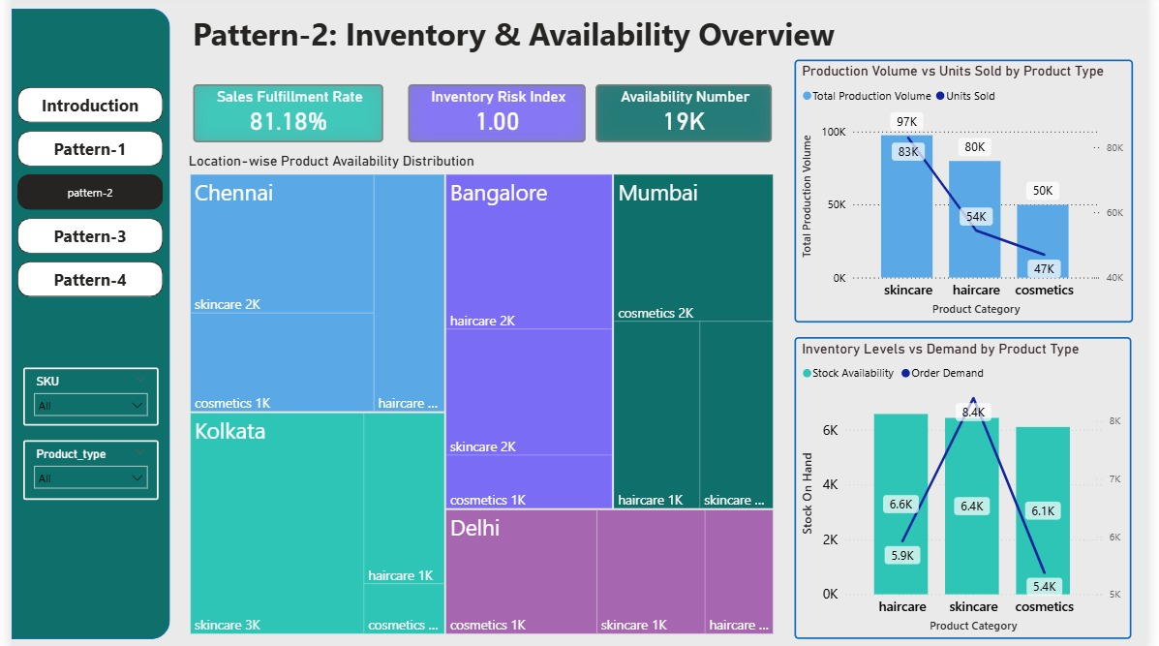
The following section presents the KPIs used, the underlying measures, business interpretation, key insights, and a summary of inventory and availability performance.
- KPIs used:

- Sales Fulfillment Rate:
Measures the percentage of customer demand that is successfully fulfilled from available stock. Indicates service level performance and effectiveness of inventory planning.

- Inventory Risk Index:
Represents the level of risk arising from overstocking or understocking. Helps identify potential revenue loss due to stockouts or holding cost due to excess inventory.

- Availability Number (Stock on Hand):
Shows the total quantity of products currently available in inventory. Supports replenishment planning and stock optimization decisions.

- Total Production Volume:
Measures the total quantity of goods produced by product category. Indicates supply capacity and production planning effectiveness.

- Units Sold (Demand):
Represents total customer demand fulfilled through sales. Used to assess how well production aligns with market demand.

- Stock vs Demand Ratio:
Compares inventory levels with customer demand. Helps identify overstock and stockout risks by product type.

- Location wise Product Availability:
Shows inventory distribution across cities and product categories.
Highlights regional imbalances and fulfillment risks.

- Measures used:

- Sales Fulfillment Rate
= DIVIDE(SUM(Units_Sold), SUM(Order_Demand)) × 100

- Inventory Risk Index
= Derived based on deviation between stock availability and demand
(e.g., absolute difference or normalized imbalance indicator)

- Stock on Hand= SUM(Stock_Levels)

- Total Production Volume= SUM(Production_Volumes)

- Units Sold= SUM(Number_of_Products_Sold)

- Stock vs Demand Ratio= DIVIDE (Stock_Available, Order_Demand)

- Location wise Availability
= SUM(Stock_Levels) grouped by Location and Product_Type

- Business Interpretation:

This section evaluates how well inventory supply aligns with customer demand across product categories and locations. By comparing production volumes, stock availability, and units sold, the analysis highlights potential overstock and stockout situations. The inclusion of fulfilment rate and inventory risk indicators provides a service level and risk-oriented view of inventory health, supporting more balanced and responsive inventory management decisions.

- Key insights:

- Sales fulfilment rate of 81.18% indicates moderate service performance, suggesting that nearly one-fifth of customer demand is not being fulfilled from available stock.
- Inventory Risk Index of 1.00 signals a balanced but sensitive inventory position, where small demand or supply shifts could create stockouts or excess inventory.
- Skincare shows the highest production volume and units sold, confirming strong demand but also increased dependency on accurate forecasting.
- Haircare and cosmetics display noticeable gaps between production and sales, indicating possible demand misalignment or overproduction.
- Stock availability exceeds demand for haircare and cosmetics, pointing toward overstock risk and higher holding costs.
- Skincare demand is higher than stock availability, highlighting potential stockout risk and lost revenue opportunity.
- Kolkata and Chennai hold relatively higher inventory levels, indicating possible regional overstocking.
- Mumbai shows comparatively lower availability across product types, increasing fulfilment risk in that region.

- Summary:

The Inventory & Availability analysis reveals an imbalance between supply and demand across product categories and locations. While skincare demonstrates strong demand, current stock levels may be insufficient to meet customer needs, creating a stockout risk. In contrast, haircare and cosmetics exhibit signs of overstocking, which can increase holding costs and working capital requirements. Regional inventory imbalances further contribute to service-level risks. These findings highlight the need for improved demand forecasting, dynamic replenishment strategies, and location wise inventory rebalancing to enhance service performance and reduce inventory risk.

Pattern-3: Manufacturing and Quality analysis:
This section evaluates manufacturing operations and quality outcomes across products and locations to assess production efficiency, process stability, and their impact on cost and service performance.
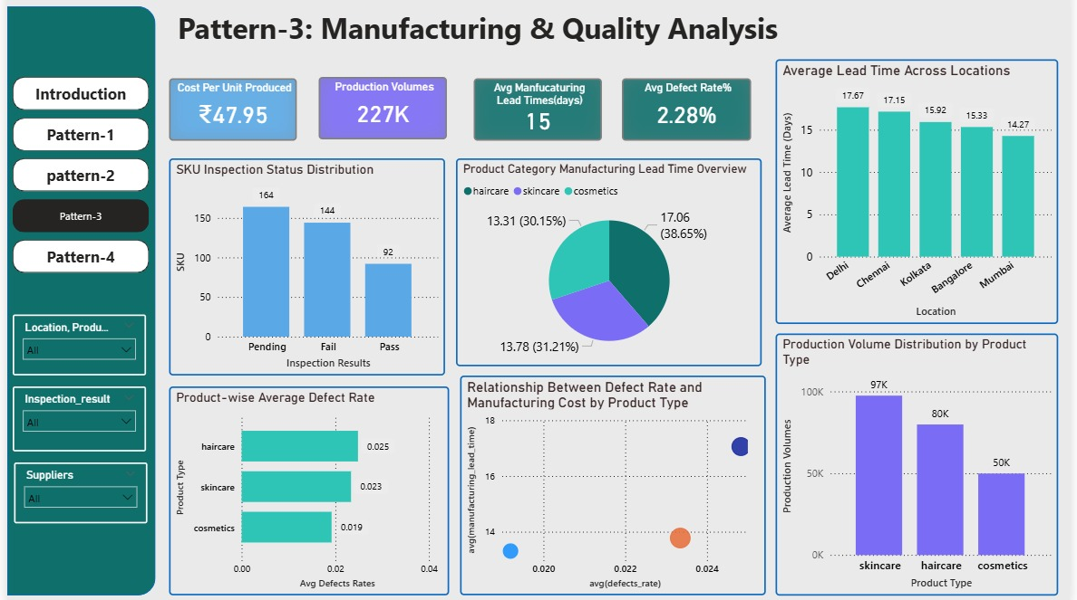
The following section presents the KPIs used, the underlying measures, business interpretation, key insights, and a summary of manufacturing and quality performance.

- KPIs used:

- Cost per Unit Produced:
Measures the average cost incurred to manufacture one unit of product. Indicates production efficiency and cost control effectiveness.

- Production Volume:
Represents the total quantity of products manufactured. Reflects manufacturing capacity utilization and output scale.

- Average Manufacturing Lead Time:
Measures the average number of days required to manufacture a product. Impacts order fulfillment speed, planning accuracy, and responsiveness.

- Average Defect Rate (%):
Represents the percentage of defective units out of total production. Indicates overall product quality and process stability.

- Inspection Status Distribution:
Shows the count of SKUs by inspection result (Pass, Fail, Pending). Highlights quality compliance and operational bottlenecks in inspection.

- Product-wise Average Defect Rate:
Compares defect rates across product categories. Helps identify quality risk by product type.

- Manufacturing Lead Time by Location:
Shows average production lead time across manufacturing locations.
Highlight’s location level efficiency variations.

- Production Volume by Product Type:
Displays production output distribution across product categories.
Supports capacity and portfolio planning decisions.

- Defect Rate vs Manufacturing Cost Relationship:
Examines the relationship between defect rates and production cost.
Identifies whether quality issues are driving higher costs.

- Measures used:

- Cost per Unit Produced
= DIVIDE(SUM(Manufacturing_Costs), SUM(Production_Volumes))

- Production Volume
= SUM(Production_Volumes)

- Average Manufacturing Lead Time
= AVERAGE(Manufacturing_Lead_Time)

- Average Defect Rate (%)
= AVERAGE(Defect_Rates) × 100

- Inspection Status Count
= COUNT(SKU) grouped by Inspection_Result

- Product-wise Average Defect Rate
= AVERAGE(Defect_Rates) grouped by Product_Type

- Manufacturing Lead Time by Location
= AVERAGE(Manufacturing_Lead_Time) grouped by Location

- Production Volume by Product Type
= SUM(Production_Volumes) grouped by Product_Type

- Business interpretation:
This section evaluates manufacturing performance and product quality across product categories and locations. By combining cost, volume, lead time, and defect metrics, the analysis provides a holistic view of production efficiency and process reliability. The inclusion of inspection outcomes and defect to cost relationships enables identification of quality driven cost escalation and operational bottlenecks, supporting more informed production planning and quality improvement initiatives.

- Key insights:
- The average cost per unit is ₹47.95, indicating moderate production cost levels but with potential optimization opportunities.
- Skincare has the highest production volume, reflecting strong demand alignment but increasing exposure to capacity and quality risks.
- Haircare exhibits the highest average defect rate, making it the most quality-sensitive product category.
- Cosmetics shows the lowest defect rate, indicating more stable production quality.
- A significant number of SKUs are either pending or failing inspection, highlighting quality control bottlenecks and delayed product release risk.
- Delhi and Chennai have the highest manufacturing lead times, indicating slower production cycles and potential capacity or process inefficiencies.
- Mumbai shows the lowest average manufacturing lead time, making it the most efficient production location.
- Higher defect rates are associated with higher manufacturing costs, confirming that quality issues are contributing to cost escalation.
- Summary:
The Manufacturing & Quality analysis highlights that while production volumes are strong particularly for skincare quality variability and lead time inefficiencies pose operational and financial risks. Haircare emerges as the most quality sensitive category due to its elevated defect rate, while a high number of pending and failed inspections signal process bottlenecks in quality control. Location wise disparities in manufacturing lead times further indicate uneven operational efficiency. These findings underscore the need for targeted quality improvement programs, process standardization across locations, and defect reduction initiatives to enhance production efficiency, control costs, and improve overall supply chain reliability.

Pattern-4: Logistics and Transportation Analysis:
This section examines logistics and transaction performance across carriers, transportation modes, and SKUs to assess delivery efficiency, cost effectiveness, lead time variability, and overall service reliability.

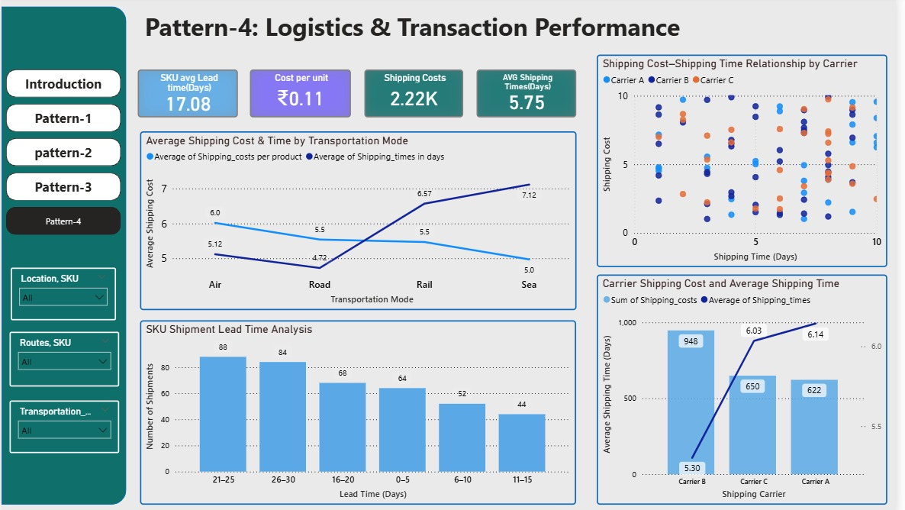

The following section presents the KPIs used, the underlying measures, business interpretation, key insights, and a summary of logistics and transaction performance.

- KPIs used:

- Average SKU Lead Time (Days):
Measures the average time taken from order placement to delivery at the SKU level. Indicates overall supply chain responsiveness and fulfillment efficiency.

- Cost per Unit Shipped:
Represents the average logistics cost incurred per unit shipped. Helps evaluate transportation cost efficiency and pricing impact.

- Total Shipping Costs:
Measures the total cost incurred for transporting goods. Indicates the scale of logistics expenditure.

- Average Shipping Time (Days):
Measures the average number of days required to ship products to customers. Directly impacts customer satisfaction and service reliability.

- Average Shipping Cost by Transportation Mode:
Compares shipping costs across air, road, rail, and sea. Supports transportation mode optimization decisions.

- Average Shipping Time by Transportation Mode:
Compares delivery times across transportation modes. Highlights trade-offs between cost and speed.

- Carrier-wise Shipping Cost:
Measures total shipping cost incurred by each carrier. Supports carrier selection and contract negotiation.

- Carrier-wise Average Shipping Time:
Measures average delivery time for each carrier. Indicates service reliability by carrier.

- SKU Shipment Lead Time Distribution:
Shows the distribution of shipments across different lead time buckets.
Highlights delay patterns and fulfillment consistency.

- Shipping Cost vs Shipping Time Relationship:
Examines the relationship between logistics cost and delivery time. Identifies cost time efficiency trade-offs.

- Measures used:
- Average SKU Lead Time= AVERAGE(Lead_Times)

- Cost per Unit Shipped
= DIVIDE(SUM(Shipping_Costs), SUM(Units_Shipped))

- Total Shipping Costs= SUM(Shipping_Costs)

- Average Shipping Time= AVERAGE(Shipping_Times)

- Average Shipping Cost by Mode
= AVERAGE(Shipping_Costs) grouped by Transportation_Mode

- Average Shipping Time by Mode
= AVERAGE(Shipping_Times) grouped by Transportation_Mode

- Carrier-wise Shipping Cost
= SUM(Shipping_Costs) grouped by Shipping_Carrier

- Carrier-wise Average Shipping Time
= AVERAGE(Shipping_Times) grouped by Shipping_Carrier

- SKU Led Time Distribution
= COUNT(SKU) grouped by Lead_Time_Buckets

- Business Interpretation:
This section evaluates logistics efficiency, delivery reliability, and transportation cost performance across carriers, transportation modes, and SKUs. By combining lead time, shipping cost, and shipment volume metrics, the analysis highlights cost service trade-offs and identifies operational bottlenecks in distribution. The carrier wise and mode wise breakdowns support data backed decisions for optimizing logistics strategy and improving service levels.

- Key insights:

- The average SKU lead time is 17.08 days, indicating relatively slow order-to-delivery performance and scope for lead time reduction.

- The average shipping time is 5.75 days, showing that a significant portion of total lead time is consumed outside transportation, likely in order processing or dispatch delays.

- Total shipping cost stands at 2.22K, representing a meaningful logistics expense component.

- Sea transport has the lowest shipping cost but the highest delivery time, indicating a cost efficient but slow transportation option.

- Air transport is the fastest but also one of the most expensive modes, reflecting a clear cost speed trade-off.

- Carrier B incurs the highest shipping cost but offers the lowest average delivery time, suggesting premium pricing for faster service.

- Carrier A and Carrier C have similar delivery times but different cost profiles, indicating an opportunity for cost optimization through carrier rebalancing.

- A large number of shipments fall in the 21-to-30-day lead time bucket, confirming fulfillment delays and service-level risk.

- There is no strong linear relationship between shipping cost and delivery time, suggesting inefficiencies and inconsistent pricing across routes and carriers.

- Summary:

The Logistics & Transaction analysis reveals that overall fulfillment performance is constrained by long lead times and inconsistent cost time efficiency across transportation modes and carriers. While premium options such as air transport and Carrier B provide faster delivery, they do so at significantly higher costs. At the same time, a large proportion of shipments experience extended lead times, creating service reliability risks. These findings highlight the need for better carrier selection, transportation mode optimization, and process improvements in order dispatch and routing to reduce lead times, control logistics costs, and enhance customer service levels.

CROSS-PATTERN BUSINESS INSIGHTS

This section synthesizes insights across sales, inventory, manufacturing, and logistics to highlight structural dependencies, performance gaps, and systemic inefficiencies within the supply chain. Cross-pattern business insights are essential for understanding how interactions between sales demand, inventory planning, manufacturing operations, and logistics execution shape end-to-end supply chain performance and business outcomes.
Following are the ways in which cross-pattern business insights can be explained:
- Sales vs. Inventory alignment
- Inventory vs. Manufacturing dependencies
- Manufacturing vs. Logistics impact
- End to end supply chain observations
In detail:
Sales vs. Inventory Alignment:
- Skincare dominates both revenue and unit sales, positioning it as the primary growth and demand engine for the business.
- Inventory levels for skincare are not consistently proportional to its sales velocity across locations, creating stockout risk and revenue leakage.
- Haircare and cosmetics carry relatively higher inventory despite lower demand, indicating inefficient capital deployment and excess holding costs.
- The disconnect between sales trends and inventory distribution reflects gaps in demand-driven planning and replenishment effectiveness.

Inventory vs. Manufacturing Dependencies:
- Manufacturing volumes are highest for skincare, aligning with its strong sales performance and reinforcing its role as the primary demand driver.
- Despite higher production output for skincare, inventory distribution across locations remains uneven, indicating weak synchronization between production planning and stock positioning.
- Higher defect rates in haircare and skincare reduce the proportion of usable finished goods, indirectly constraining inventory availability and service levels.
- Variability in manufacturing lead times across locations limits the organization’s ability to replenish inventory quickly for high-velocity products.
- Elevated production costs and longer lead times in specific product categories increase the risk of inventory imbalances and planning inefficiencies.

Manufacturing vs. Logistics Dependencies:
- Longer manufacturing lead times for certain product categories directly extend downstream shipping lead times, reducing overall order responsiveness.
- Variability in production lead times across locations weakens logistics planning accuracy and increases uncertainty in delivery commitments.
- Higher defect rates in manufacturing increase rework and reshipment volumes, indirectly driving up logistics workload and transportation costs.
- Elevated production costs in specific categories amplify the financial impact of inefficient transportation modes and carrier selection.
- Mismatch between production completion schedules and shipment dispatch timing creates idle inventory, transit delays, and avoidable handling costs.

End to End supply chain observations:
- Demand is heavily concentrated in skincare, while upstream production, inventory allocation, and downstream logistics execution are not consistently synchronized to support this demand pattern.
- Misalignment between sales velocity and inventory positioning across locations is creating both revenue leakage in high-demand products and excess holding costs in slower-moving categories.
- Variability in manufacturing lead times and defect rates is weakening replenishment responsiveness and reducing effective finished-goods availability.
- Logistics cost and lead-time inefficiencies are amplifying the operational impact of upstream production and planning gaps.
- Weak end-to-end demand-driven planning is limiting service levels, increasing working capital tied up in inventory, and constraining overall supply chain efficiency.

BUSINESS RECOMMENDATIONS

- Institutionalize demand-driven inventory allocation processes that help rebalance inventory for high-velocity SKUs, primarily skincare categories, as well as high-demand locations.
- Incorporate sales-driven synchronized replenishment planning to match inventory cycles to genuine trends, helping to maximize inventory turnover and liberate tied-up working capital.
- Realign manufacturing output to correspond with demand signals by focusing on high growth SKU demand and dampening output for structurally weaker ones.
- Stabilize and shorten manufacturing lead times by standardizing scheduling and production planning best practices for improving responsiveness and dependability of product replenishment.
- Improve quality management programs to lower deficiency rates for those categories, thereby increasing finished goods yield and optimum inventory availability.
- Bring together production execution with logistic execution to synchronize dispatch schedules with production completion, thereby avoiding idle inventory.
- Consider adopting a cost to serve-based logistics strategy to optimize carrier choice and mode while trying to meet service level, lead time, and cost.
- To establish an endpoint planning and governance system that links the areas of sales, production, inventory, logistics, and so on, to a long-run performance management system.

CHALLENGES DURING EXECUTION

- Data Quality and Consistency Issues:
The dataset contained missing values, inconsistent naming conventions, and uneven granularity across fields such as SKUs, locations, and product categories, which required extensive cleaning and standardization.
- Lack of a Clear Data Dictionary:
The absence of metadata and business definitions for key fields (e.g., demand, availability, defect rate, and lead time) made it challenging to interpret variables accurately and align KPIs with business meaning.
- Ambiguity in KPI Definitions:
Certain KPIs such as Inventory Risk Index, Fulfillment Rate, and Defect Rate required assumptions and custom logic, as their calculation rules were not explicitly defined in the dataset.
- Data Modeling Complexity:
Designing a clean and scalable data model that supported cross-functional analysis across sales, inventory, manufacturing, and logistics required careful handling of relationships and aggregation logic.
- Measure Design and Validation in Power BI:
Developing accurate DAX measures for KPIs such as average revenue per SKU, cumulative revenue percentage, and stock-to-demand ratios involved multiple iterations and validation checks.
- Handling Granularity Mismatches Across Tables:
Some metrics were recorded at SKU level, while others were at product category or location level, making it difficult to ensure consistent aggregation and avoid misleading insights.
- Visualization Design and Layout Constraints:
Fitting multiple KPIs and charts into a limited dashboard space while maintaining readability, visual hierarchy, and analytical clarity required several layout refinements.

- Balancing Detail with Interpretability:
Ensuring that dashboards remained analytically rich without overwhelming users with excessive metrics and visuals required selective KPI prioritization.
- Ensuring Business Relevance of Insights:
Translating analytical outputs into business-meaningful insights rather than purely technical observations required repeated refinement of interpretation.
- Performance Optimization in Power BI:
Certain visuals and complex measures initially caused slow rendering, requiring optimization of DAX logic and visual interactions.

CONCLUSION

- The analysis reveals a structurally demand-led business, with skincare emerging as the primary revenue and volume driver across the supply chain.
- Persistent misalignment between sales velocity and inventory allocation is creating both revenue leakage in high-demand categories and excess holding costs in slower-moving products.
- Manufacturing output broadly supports demand trends but is constrained by lead-time variability and quality inefficiencies that weaken replenishment responsiveness.
- Elevated defect rates in high-volume categories are reducing effective finished-goods availability and increasing operational waste.
- Logistics execution shows cost–time trade-offs and carrier variability that amplify the impact of upstream planning and production inefficiencies.
- Weak synchronization between sales forecasting, production planning, inventory positioning, and logistics execution limits overall supply chain agility.
- The absence of demand-driven planning and SKU-level governance is constraining service levels, inventory turnover, and working capital efficiency.
- Overall, the supply chain exhibits strong growth potential, but requires tighter end-to-end integration, demand-synchronized planning, and operational discipline to achieve sustainable performance improvement.

